 | 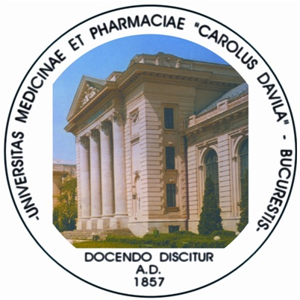 |  | 

International Training Course
Electroporation for Medicine: Basic Knowledge, Applications and Technologies

October 25-27, 2012

REGISTRATION FORM
Please fill it with CAPITAL letters and send as Microsoft Word document attachment
to rspab@biophysicsnet.ro or by Fax before October 23, 2012
Fax No. +40-21-3125955

First name
Last name
Year of birth
Gender Female Male
PhD Yes (year of defense) No
Profession/Title
Institution
Address
Phone no
Fax no
E-mail address

